**WRITE A PROGRAM TO PRINT TO DO LIST APPLICATION USING PYTHON**

**AIM:**TO CREATE A PROGRAM TO PRINT THE TO DO LIST APPLICATION

**ALGORITHM:**

Step 1: First, we will import all the modules required to build the project.

Step 2: We will then define some functions necessary to execute the application.

Step 3: We will then create a main window for the application.

Step 4: We will then add a database to the application to store the data.

PROGRAM:

class ToDoList:

def _init_(self):

self.tasks = []

def add_task(self, task):

self.tasks.append(task)

print(f"Task '{task}' added to the to-do list.")

def view_tasks(self):

if not self.tasks:

print("No tasks in the to-do list.")

else:

print("To-Do List:")

for index, task in enumerate(self.tasks, start=1):

print(f"{index}. {task}")

def remove_task(self, index):

if 1 <= index <= len(self.tasks):

removed_task = self.tasks.pop(index - 1)

print(f"Task '{removed_task}' removed from the to-do list.")

else:

print("Invalid index. Please provide a valid task index.")

# Main function to run the to-do list application

def main():

todo_list = ToDoList()

while True:

print("\nMenu:")

print("1. Add Task")

print("2. View Tasks")

print("3. Remove Task")

print("4. Exit")

choice = input("Enter your choice (1-4): ")

if choice == '1':

task = input("Enter the task: ")

todo_list.add_task(task)

elif choice == '2':

todo_list.view_tasks()

elif choice == '3':

index = int(input("Enter the index of the task to remove: "))

todo_list.remove_task(index)

elif choice == '4':

print("Exiting the to-do list application. Goodbye!")

break

else:

print("Invalid choice. Please enter a number between 1 and 4.")

if _name_ == "_main_":

    main()

**OUTPUT:**

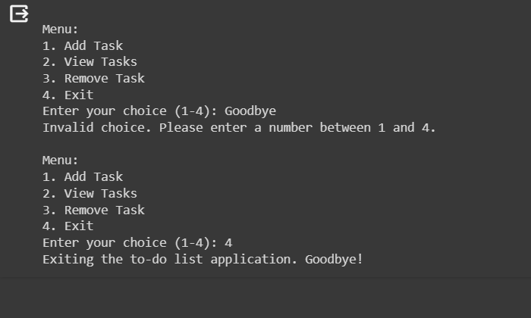

**RESULT:**

**Thus ,The Python Program to do list application in python was executed and the output is verified successfully**